**CREATING A PROMO VIDEO USING CANVA**

**TABLE OF CONTENTS:**

1. Introduction

2. Planning of Promo Video

3. Getting Started with Canva

4. Designing Promo Video

5. Adding Content

6. Enhancing Video

7. Finalizing Promo Video

8. Conclusion

**1. INTRODUCTION:**

Promo videos are a powerful way to market your products, services, or events. Canva, a popular graphic design and video editing tool, offers a user-friendly platform for creating engaging and professional-looking promo videos. In this report, we'll walk you through the steps to create a promo video using Canva.

**2. PLANNING YOUR PROMO VIDEO:**

Before diving into Canva, it's essential to plan your promo video. Define your target audience, message, and the desired length of your video. Consider the tone, style, and any branding elements you want to incorporate.

**3. GETTING STARTED WITH CANVA:**

**1. Create an Account:** If you haven't already, sign up for a Canva account. Canva offers a free version and a Pro version with advanced features.

**2. Select "Create a Design":** In Canva, select "Create a Design" and choose "Custom Dimensions" for your video. Standard video dimensions are 1080x1920 pixels (9:16), but Canva provides various preset options.

**3. Choose a Template**: Canva offers a vast library of video templates. Pick a template that suits your project and vision.

**4. DESIGNING YOUR PROMO VIDEO:**

**1. Customize the Template:** Modify the template to fit your brand and message. Change colors, fonts, and layout to align with your style.

**2. Add Background Music**: Canva provides a selection of royalty-free music. Choose a track that complements your video's mood and message.

**5. ADDING CONTENT:**

**1. Upload Media:** Import your images, videos, and graphics. Canva supports various file formats.

**2. Drag and Drop:** Arrange your content in the desired order. Canva allows you to layer and position elements precisely.

**3. Text and Captions:** Add text boxes to convey your message. Adjust fonts, sizes, and colors for readability.

**6. ENHANCING YOUR VIDEO:**

**1. Transitions:** Canva offers a variety of transitions between scenes. Use these to make your video flow seamlessly.

**2. Animations:** Apply animations to text and elements to make your video more dynamic.

**3. Filters and Effects:** Experiment with filters and effects to enhance the visual appeal of your video.

**7. FINALIZING YOUR PROMO VIDEO:**

**1. Preview and Edit:** Review your video and make any necessary adjustments.

**2. Export:** Once you're satisfied, export your video in your preferred format. Canva offers options for different platforms and quality settings.

**3. Share Your Video:** You can share your video directly from Canva or download it to your device for further distribution.

**8. CONCLUSION:**

Creating a promo video using Canva is a creative and straightforward process that can yield impressive results. By following the steps outlined in this report and experimenting with Canva's tools, you can craft a visually appealing and effective promo video to promote your products, services, or events.

Remember to keep your target audience and message in mind throughout the process, and don't hesitate to revisit and refine your video until it perfectly conveys your intended message. Canva's user-friendly platform and vast resources make it an excellent choice for creating engaging and professional promo videos.

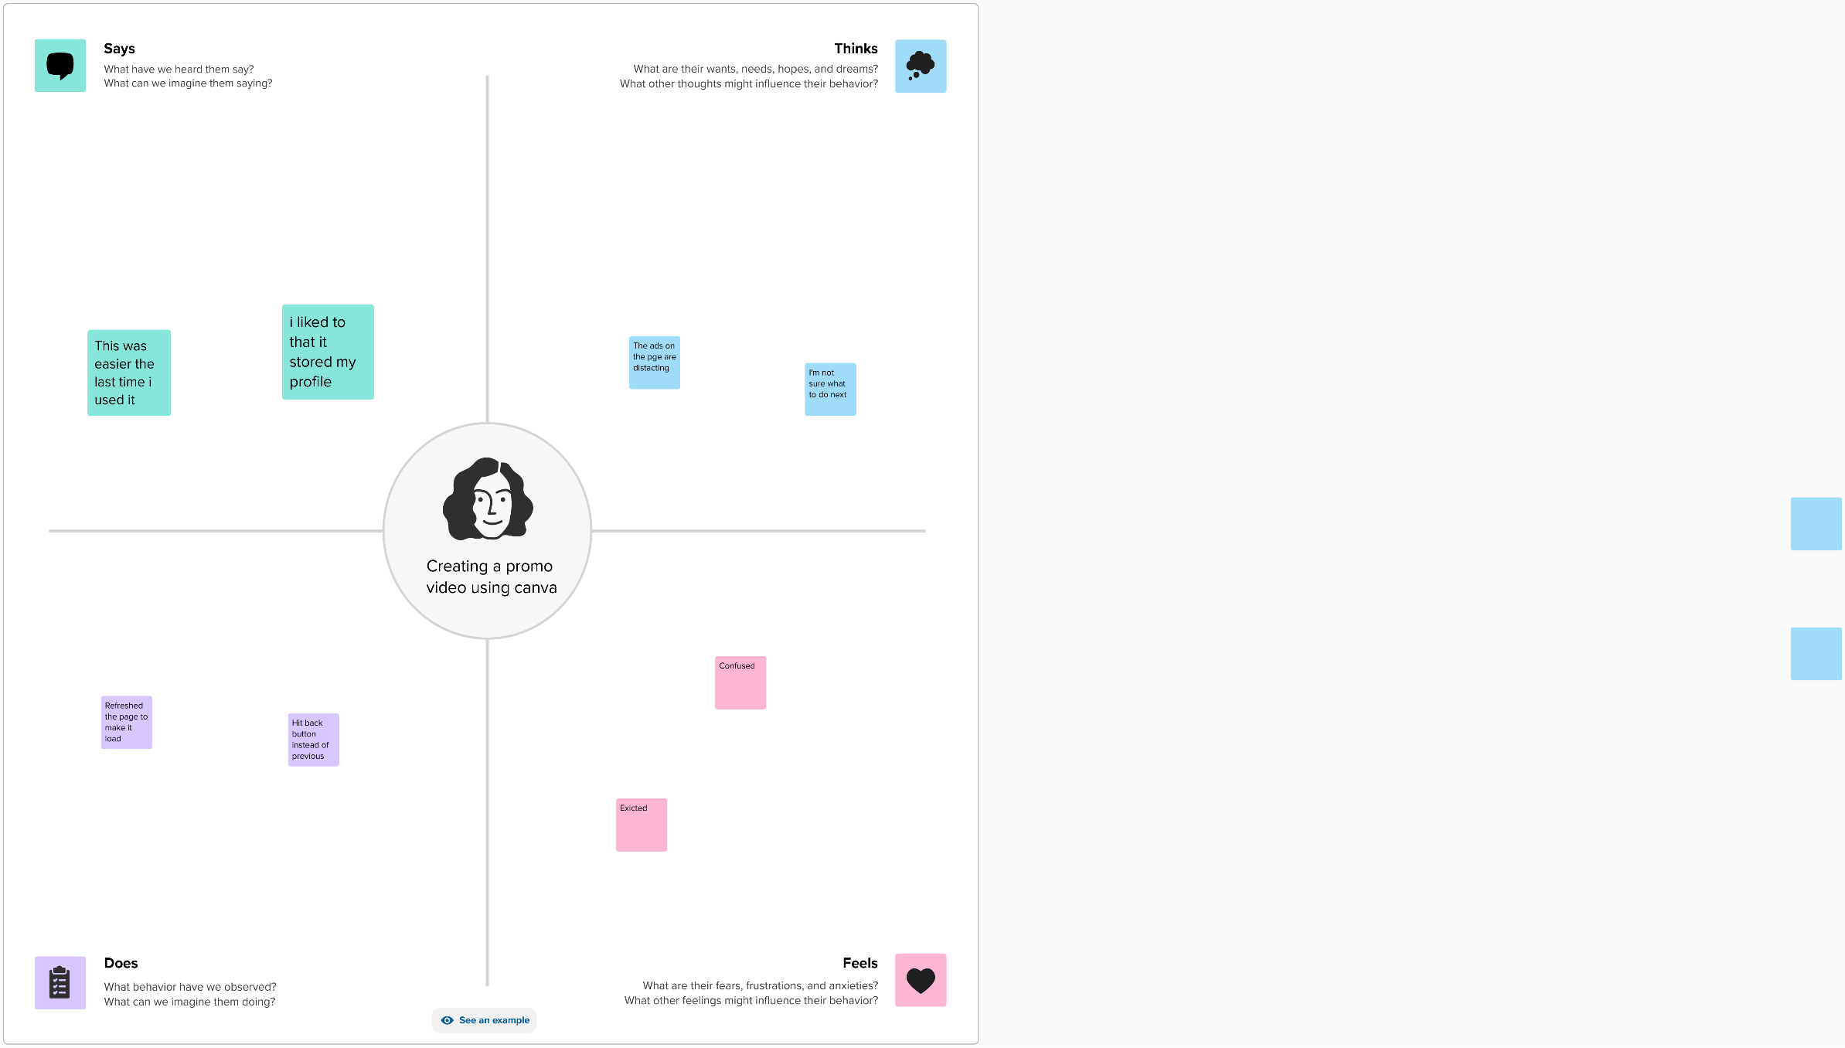

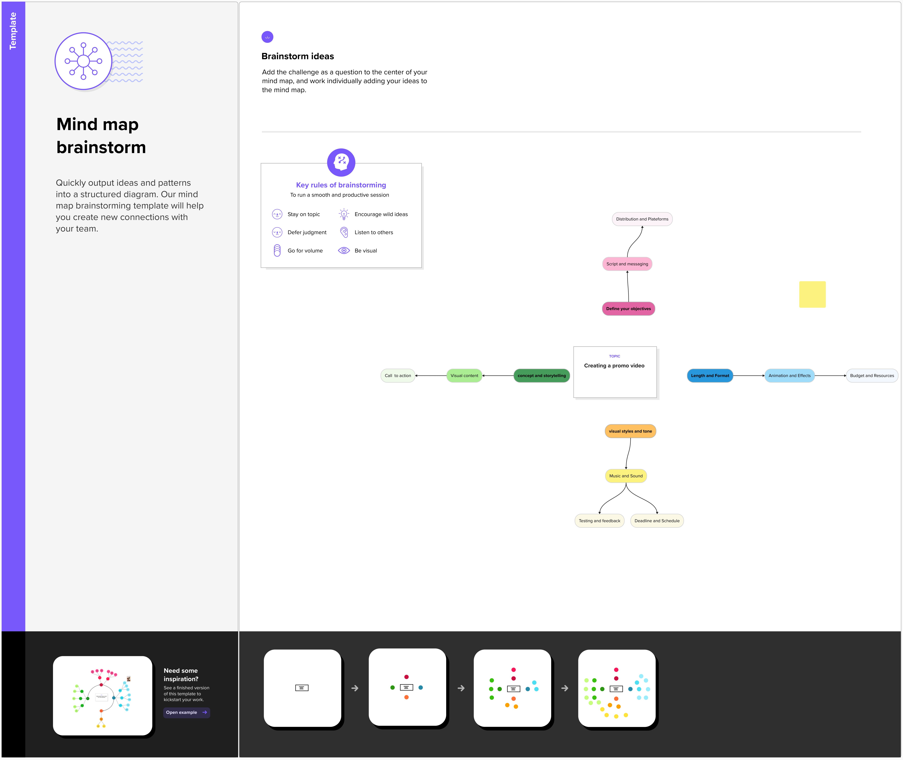

**RESULT**

